**LAB 4:**

**PRELAB:**

1. What are different types of informed searches? Explain about them brief?

2.Differentiate the approach of Greedy BFS and A* BFS on the given tree and compare their time and space complexities.

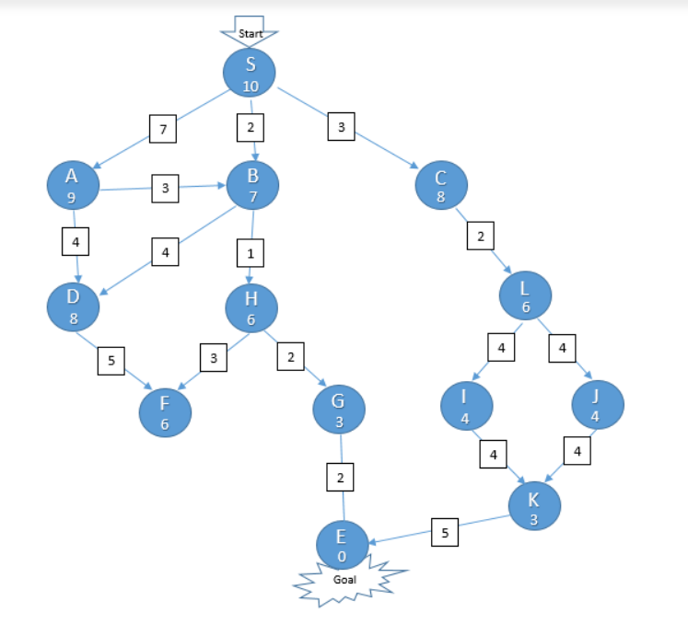

**INLAB:**

1. Write a python program to find the path in the following maze using A* algorithm,considering 1 as the wall and 0 as the movable region.

maze = [[0, 0, 0, 0, 1, 0, 0, 0, 0, 0],

[0, 0, 0, 0, 1, 0, 0, 0, 0, 0],

[0, 0, 0, 0, 1, 0, 0, 0, 0, 0],

[0, 0, 0, 0, 1, 0, 0, 0, 0, 0],

[0, 0, 0, 0, 1, 0, 0, 0, 0, 0],

[0, 0, 0, 0, 0, 0, 0, 0, 0, 0],

[0, 0, 0, 0, 1, 0, 0, 0, 0, 0],

[0, 0, 0, 0, 1, 0, 0, 0, 0, 0],

[0, 0, 0, 0, 1, 0, 0, 0, 0, 0],

[0, 0, 0, 0, 0, 0, 0, 0, 0, 0]]

start = (0, 0)

end = (7, 6)

Output:

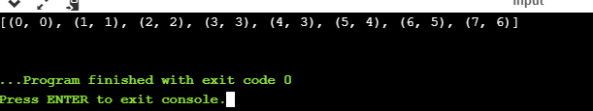

**POSTLAB:**

1. Write a python program in which the system tries to reach and generate the sentence “Hello, World!”. You have to print the difference of the sentence generated in that step and the actual sentence at each step.

Sample Output:

